CityGarage Manager’s Special
VALVOLINE MAXIFE
FULL SYNTHETIC Oil Change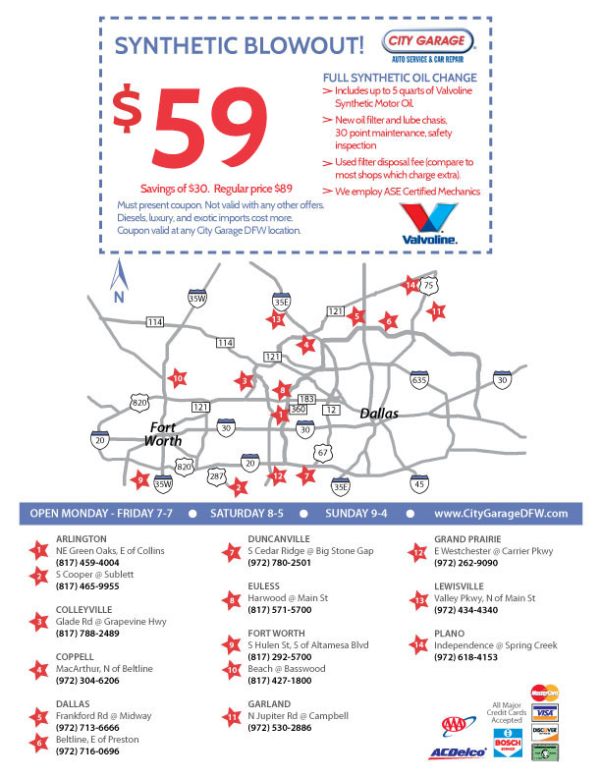
ONLY $59.00!!!(UP TO 5QTS)

